Draw these organic compounds on a separate sheet of paper and write the function of each below each drawing. Use your notes to help you.
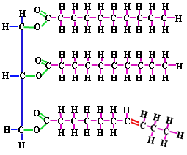 LIPID

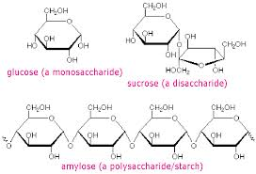CARBOHYDRATE

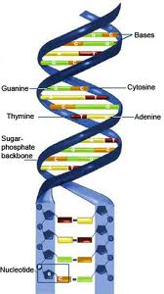NUCLEIC ACID

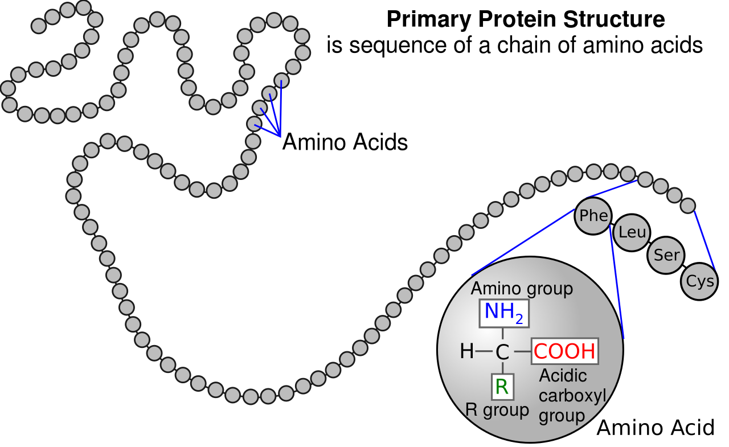PROTEIN

